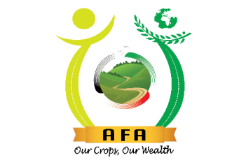


MINISTRY OF AGRICULTURE AND LIVESTOCK DEVELOPMENT

STAKEHOLDERS’ COMMENT(S) FORM

COMMENTS FORM ON THE CROPS (NUTS AND OIL CROPS) (AMENDED) REGULATIONS, 2025

Name of stakeholder (Optional) ………………………………………………………………………………………………….

Stakeholder category (INDICATE) ………………………………………………………………………………………………………………………
(e.g. CBO/farmer/NGO/Academia University/County Department etc.)

County………………………………………………………. Date …………………………………………...

Section/Page  e.g. Clause 1/ Pg. 3 | Issue/comment | Stakeholder proposed recommendation/change
Email additional Comments to: infonocd@afa.go.ke

For further clarification contacts
Email or/& Mobile phone (Optional) ………………………………………………………………………………………………………………
Thank you for the Feedback

